**How to Schedule a Team Practice in Sports Connect:**

1. From the home page, select Team Directory.



1. 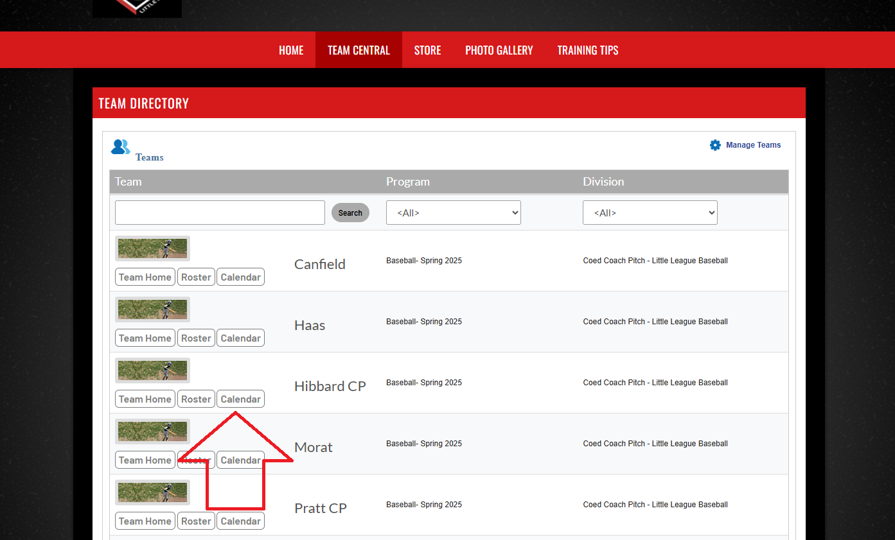Find your team and select Calendar.
2. From your team page, select Create Event.

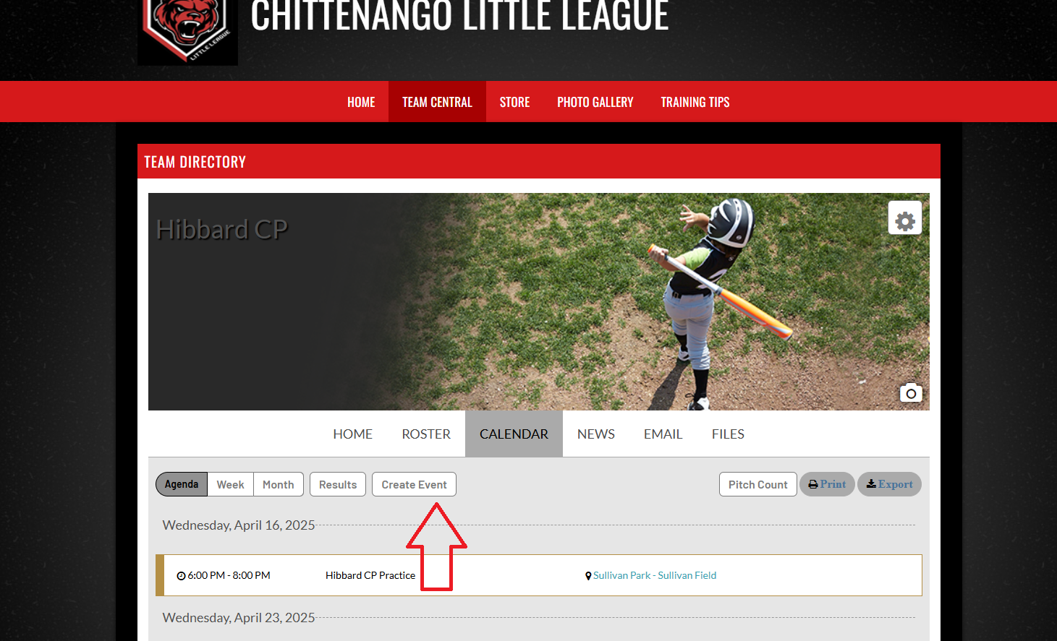

1. Select Practice and click Continue.

1. Select the field location, date, time and length of practice. Click Save and your team will automatically be notified.

Email [chittenangolittleleague@gmail.com](mailto:chittenangolittleleague@gmail.com) with any questions.